ATTACHMENT 1
FRANCHISE INFORMATION
1. Territory. The Territory is a geographic area in the province of Ontario, as outlined on the map attached to and forming part of this Attachment 1, and/or consisting of the following postal codes or forward sortation areas as of the Effective Date: October 31, 2024
L4T, L4V, L4W, L4X, L4Y, L4Z, L5A, L5B, L5C, L5E, L5G, L5H, L5J, L5K, L5L, L5M, L5N, L5P, L5R, L5S, L5T, L5V, L5W
2. Franchisee's Owners. The following is a list of shareholders, partners, or other investors in Franchisee, including all investors who own or hold a direct or indirect interest in Franchisee, and a description of the nature of their interest:
Name | Ownership Percentage | Nature of Interest
Kevin Mako | 51 | Direct
Brenda Rosati | 49 | Direct

3. Franchisee's Related Parties. The following is a list of Franchisee's Related Parties, each of whom will execute the Agreement and Guaranty substantially in the form set forth in Attachment 4 and/or a Confidentiality Agreement and Ancillary Covenants Not to Compete, as determined by Franchisor in its sole judgment.
Name | Interest

ATTACHMENT 1
LEGAL*65740976.2
Docusign Envelope ID: 54DB36E5-EEC0-4694-92AD-B0D3B6C690F7
ATTACHMENT 1 (CONTINUED) – TERRITORY MAP
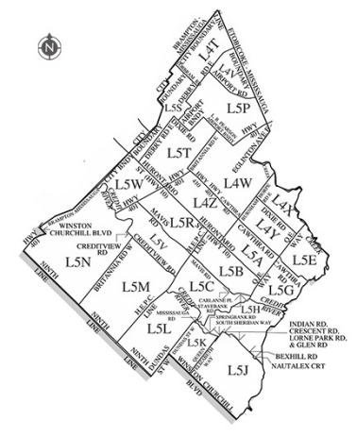
ATTACHMENT 1
LEGAL*65740976.2
Docusign Envelope ID: 54DB36E5-EEC0-4694-92AD-B0D3B6C690F7

